Developing a Pivot Divergence Strategy with Order Flow (Donchian + CVD)

Baseline Strategy: Pivot Divergence at Donchian Extremes
The provided Pine Script indicator implements a mean-reversion strategy that looks for exhaustion at the extremes of a price range. In simple terms, it waits for price to reach the edge of a Donchian channel and form a confirmed pivot (local high/low), then checks for a momentum divergence at that pivot. Only if all conditions align does it signal a trade in the opposite direction (long at a low, short at a high). This approach aims to catch false breakouts or reversals – when price briefly makes a new extreme but lacks real power to continue[1]. Key components of the baseline strategy are:
- Donchian Channel Context: Calculate a Donchian channel (e.g. 120-bar high/low). Compute a normalized position of the latest price within this range (loc from 0 to 1). The strategy only considers pivots that occur near the extremes of the range: for a long setup, the pivot low must be in the bottom X% of the range (e.g. loc <= 0.10 for a 10% band); for a short, the pivot high must be in the top X% (loc >= 0.90). This ensures we only trade at range edges, where reversals are more likely (the context of an extended move). Essentially, “only take reversals at the edges of the range,” filtering out mid-range noise.
- Pivot Structure (No Early Signals): Use a pivot finding function with a lookback (e.g. pivotLen = 5 bars) to identify local minima or maxima in price. A pivot low is confirmed only after pivotLen subsequent bars have higher lows, and a pivot high is confirmed after pivotLen bars of lower highs. This built-in delay means the pivot is identified retroactively – the signal is triggered only on the bar that confirms the pivot, not at the moment price touches a new high/low. In the Pine script, for example, if a pivot low is detected, the code waits pivotLen bars and then fires the long signal on the confirmation bar. This “late entry” avoids repainting or false signals (no future leakage) because it requires seeing that a true turning point occurred. The trade-off is some lag: by the time we enter, price has already moved off the extreme, incurring some slippage from the ideal bottom/top. (The Pine script even logs the basis-points difference between the pivot price and entry price as Slip(bps) to quantify this lag cost.)
- Momentum/Pressure Divergence: At the confirmed pivot, the strategy looks for a bullish or bearish divergence between price and an oscillator. In the Pine baseline, the oscillator is defined as osc = EMA((close - open) * volume, oscLen) – essentially an EMA of price change times volume (a proxy for volume-weighted momentum or pressure). For a bullish divergence at a pivot low, the price makes a lower low (or equal low) compared to the last pivot, but the oscillator makes a higher low (showing diminished selling pressure). For a bearish divergence at a pivot high, price makes a higher high but the oscillator makes a lower high (diminished buying pressure). This classic divergence pattern indicates that the new extreme in price was not confirmed by internal momentum – a warning that the move may be exhausting. In other words, the trend pushed to a new extreme without an increase in aggressive participation. This concept aligns with technical wisdom: when price breaks a range but lacks momentum or shows divergence, it often signals a false breakout and impending reversal[1].
- Entry Signal: When both “gates” align – (1) pivot occurred at a Donchian extreme and (2) divergence is present vs. the previous pivot – the strategy flags a live trade signal. A long trade is signaled on the confirmation bar after a bullish-divergence pivot low; a short trade is signaled after a bearish-divergence pivot high. Entry is taken at that bar’s close (or next open) to mimic realistic execution. The Pine script marks these with labels like “LIVE LONG” or “LIVE SHORT” on the chart. Because the signal waits for confirmation, there is no hindsight bias: in live trading you would only know about the setup after that pivot is confirmed (i.e., a few bars after the actual high/low). This methodology ensures no leakage of future data – it’s exactly how one would trade it in real time, albeit with a slight delay by design.
Why does this work? The baseline strategy is effectively capturing exhaustion at support/resistance. The Donchian channel identifies the context (price at a multi-period extreme, where one might expect a reversal). The pivot + divergence provides the trigger (evidence that the move weakened: price made a new low but an oscillator didn’t, or vice versa). This combination exploits the phenomenon that big volume surges late in a move can mark capitulation – e.g. a final big red candle on high volume as price pierces a low, but then bounces. The custom oscillator (close-open)*volume attempts to capture that “pressure” – large negative values indicate heavy selling pressure in a bar. If a new price low comes with less such pressure than a prior low, it implies sellers are drying up even as price stretches lower. The result is a high-probability reversal zone. This is conceptually similar to using RSI or volume divergence at channel extremes (a well-known reversal tactic[1]), just tailored here with a volume-weighted price move indicator.

Enhancing with Order Flow: Using Raw Bid/Ask Data (CVD)
To take this strategy to an “institutional” level, we replace or augment the synthetic oscillator with actual order flow metrics derived from tick data (e.g. Binance aggregated trades, which provide price, size, and aggressor side for each trade). Specifically, we focus on Cumulative Volume Delta (CVD) – the running difference between buying and selling volume. Institutional and professional traders often watch CVD to gauge real buying/selling pressure behind price moves[2]. By using raw bid/ask trade data, we can detect more nuanced divergences that aren’t visible on standard charts.
What is CVD? CVD tallies volume traded at the ask minus volume at the bid (or vice versa). In practice, for each trade tick we determine if it was buyer-initiated (taker lifted an ask) or seller-initiated (taker hit a bid), and add the trade volume to a cumulative sum (adding for buys, subtracting for sells). The CVD rises when aggressive buyers dominate, and falls when aggressive sellers dominate[2]. This indicator shows who is pushing the market in real time, which is invaluable for understanding potential reversals: - In a healthy uptrend, price makes higher highs and CVD should also be making higher highs (consistent aggressive buying). - If price makes a higher high but CVD fails to make a new high, it signals a lack of aggressive buyers behind the move[3]. The up move may be running on fumes (or being countered by passive sellers absorbing the demand). This is analogous to the oscillator divergence but using actual trade flow. Such a divergence (price up without buyer delta up) often precedes a pause or reversal[3]. - Likewise, if price prints a lower low but CVD doesn’t make a new low, it indicates aggressive sellers are waning – fewer market sell orders are hitting new lows[3]. Despite price dipping, the selling pressure isn’t increasing, hinting at potential exhaustion of the down move. Traders see this as no fresh willingness to sell at those lows[4], a bullish sign. - Another insight: if we observe the opposite type of divergence – absorption – it’s also telling. For example, if CVD makes an extreme (say a new low) but price doesn’t (price holds steady or a higher low), it suggests aggressive sellers were absorbed by limit buyers (heavy selling could not push price further down)[5]. This is a strong bullish signal. Similarly, CVD high without price high means aggressive buying met overhead supply and price couldn’t climb[5]. These “delta vs price” discrepancies are exactly what order flow traders monitor for reversal cues.
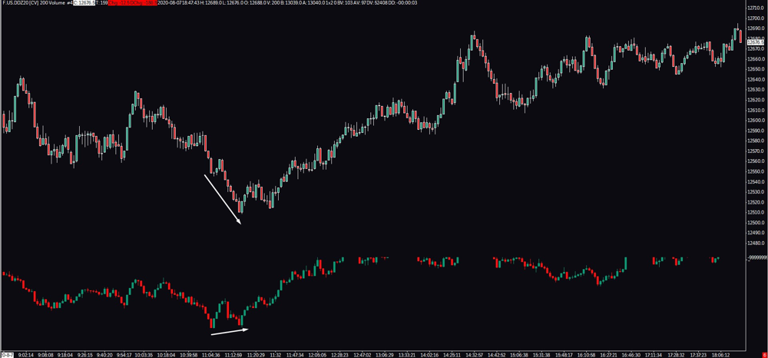
Example: The chart above illustrates a bullish CVD divergence. Price (top) made a lower low, but the CVD (bottom) made a higher low – signaling that fewer aggressive sellers participated in the second drop. This lack of selling pressure at the new low often precedes a reversal upward[3][4].
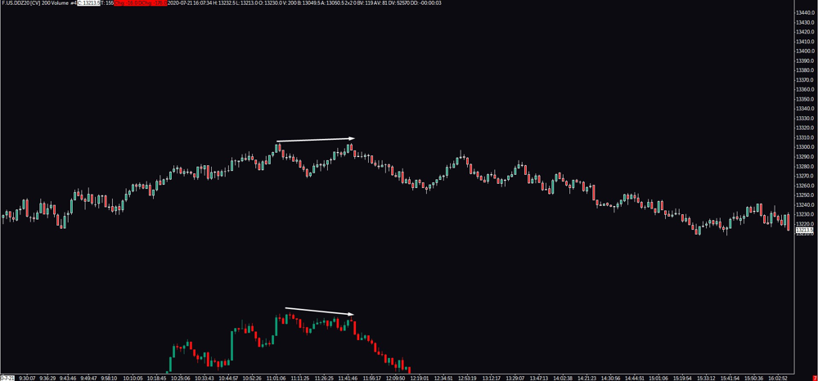
Example: The chart above shows a bearish CVD divergence. Price pushed to a higher high, yet the CVD failed to make a new high (even slightly declining). This indicates diminishing aggressive buying at the top, warning that the upmove may be out of steam[3]. Shortly after, price begins to roll over, aligning with the bearish divergence signal.
By incorporating CVD into our strategy, we align it with what institutional traders watch on the “tape”. The baseline Pine script’s EMA((close-open)vol) was a clever proxy for this idea of volume pressure – but using actual buy/sell flow data is more direct and robust. It transforms the strategy into one based on real market orders (who’s in control: buyers or sellers), not just price-derived indicators. This is especially powerful in highly liquid markets like BTC or ETH futures, where volume delta divergences often mark turning points. In summary, the strategy will use price vs. CVD divergence at Donchian pivots: we still wait for a confirmed pivot at a range extreme, but now the trigger is that price made an extreme unconfirmed by volume delta (signaling either exhaustion or absorption). This kind of order flow confirmation is considered more institutional-grade*, as it looks under the hood of the candlestick to see actual buying/selling imbalance[6][7].

Implementation Plan (Backtest & Live)
To build this strategy in practice (for backtesting on historical data and for live trading via Binance WebSocket), we need a careful step-by-step approach. The key is to replicate the Pine logic in a leakage-free manner and then integrate the CVD calculation from tick data. Below is a structured plan:
- Data Setup (Multi-Timeframe Context): Decide on the timeframes for context vs. signal. A common approach (hinted by the engineer) is using a higher timeframe for context and a lower timeframe for entries. For example:
- Macro Filter: Identify key zones or trend on a higher timeframe (e.g. 4H “zonebook”). This could be done via volume profile high-volume nodes, support/resistance levels, or simply a long-term moving average trend filter[8]. The idea is to prefer long signals when price is in a higher-timeframe support zone or uptrend, and prefer shorts at resistance or downtrend. (This step is optional but can greatly improve quality by aligning with institutional context.)
- Micro Signal Timeframe: Use a lower timeframe like 15-minute for the pivot divergence signals (as tested on BTCUSD 15m, per the Pine script). We will construct 15m bars from tick data for analysis. Ensure your historical data includes price high, low, open, close, and volume per bar, as well as the tick-level data for CVD.
- Compute Donchian Channels: On the signal timeframe (e.g. 15m bars), compute the Donchian high and low over the last N bars (e.g. 120 bars ~ 30 hours). For each new bar, update:
- donHi = highest(high, donLen)
- donLo = lowest(low, donLen)
- Normalized Location (loc) = (close - donLo) / (donHi - donLo) if the range is non-zero. This yields a value between 0.0 (price at channel bottom) and 1.0 (at top).
The strategy’s extreme band filter then checks this loc at the time of a pivot: define a threshold (say 0.10 or 10%). For a pivot low to qualify for a long, its loc should be ≤ 0.10 (meaning that pivot formed in the lowest 10% of the Donchian range). For a pivot high to qualify for a short, loc ≥ 0.90 (top 10% of range). This condition makes sure we are trading at extreme ends where false breakouts are likely, as noted in research[1].
- Calculate CVD (Aggressive Volume Delta): As you process the tick data (Binance aggTrades or similar), maintain a cumulative delta value. For each trade:
- Determine if it was a buyer-initiated or seller-initiated trade (Binance’s aggTrade data includes an isBuyerMaker flag – if true, the maker was a buyer, so the aggressor was a seller; if false, the aggressor was a buyer).
- Add the trade volume to a running total: e.g. increment CVD by +Volume for buyer-initiated trades, or -Volume for seller-initiated trades (or vice versa depending on convention).
You can do this cumulatively over the whole session, or reset CVD every day/session – but for divergence detection, what matters is the relative moves in CVD. You might maintain a bar-based CVD series as well (sum of delta per 15m bar) to align with pivot points. For instance, record the CVD value at each bar’s close. Note: CVD can be calculated on the fly in live trading from the WebSocket stream, but in backtest you’ll reconstruct it from historical trades. The goal is to know, at any given bar, the CVD value (or an oscillator of CVD) up to that point.
- Identify Pivot Highs and Lows: Implement a pivot finding mechanism similar to ta.pivotlow/high in Pine. One approach:
- Use a rolling window of length pivotLen bars on each side. For each bar i, look back pivotLen bars and forward pivotLen bars; if bar i’s low is the lowest in that span, mark it as a pivot low. If bar i’s high is the highest in that span, mark it as a pivot high.
- Alternatively, a simpler logic: a bar is a pivot low if it has pivotLen higher lows before and pivotLen higher lows after; similarly, pivot high if pivotLen lower highs on each side.
- In code, you can detect a pivot low at index j by checking low[j] == min(low[j-pivotLen : j+pivotLen]). But important: such a pivot should only be acted upon after it’s confirmable, i.e. at bar j + pivotLen (when the right-side window has passed in real time). A straightforward method in backtest is: as you iterate forward in time, at each new bar t, check if a pivot low occurred pivotLen bars ago (at t - pivotLen). If yes, that means by bar t you have confirmation of a pivot at t - pivotLen. This mirrors the Pine script’s behavior (where ta.pivotlow yields a non-na value only at the confirmation bar). Store the pivot’s price and relevant info:
- lastPivotLowPrice and lastPivotLowCVD (or last oscillator) for the most recent confirmed pivot low.
- lastPivotHighPrice and lastPivotHighCVD for the last confirmed pivot high.
- Update these when new pivots confirm. This will allow divergence comparisons with the previous pivot of the same type.
- Detect Divergence on Pivot Confirmation: When a new pivot is confirmed (on the current bar):
- If it’s a pivot low (just confirmed now at bar t, which means the actual lowest bar was t - pivotLen):
  - Retrieve the pivot’s price and the CVD value at that pivot (you could use the CVD at the pivot bar close, or perhaps intra-bar CVD minimum – but using bar close CVD is consistent). Let’s call them pivotPrice = low of t - pivotLen, and pivotCVD = CVD at t - pivotLen.
  - Check the Donchian location at that pivot (we computed loc each bar): ensure loc at t - pivotLen was ≤ extBandPct (extreme low). This is the context filter.
  - Check for a bullish divergence: Compare to the previous confirmed pivot low (if any). We require:
  - pivotPrice is not higher than the last pivot low’s price. Ideally, pivotPrice <= lastPivotLowPrice (new equal or lower low in price).
  - pivotCVD is higher than lastPivotLowCVD. This means at this new low, the CVD (cumulative buying vs selling) did not make a lower low – i.e. selling pressure was less intense than at the previous low. In other words, fewer net sellers or more buyers stepped in this time, diverging from the price action. This condition is our bullish trigger that indicates waning downside aggression[3]. (If using the original oscillator method instead: oscillator value at this pivot > oscillator at last pivot).
  - If both the above conditions are true, mark this as a valid long setup.
- If it’s a pivot high (confirmed at bar t, actual pivot at t - pivotLen):
  - Let pivotPrice = high of t - pivotLen, and pivotCVD = CVD at that pivot bar.
  - Require loc at t - pivotLen ≥ (1 - extBandPct) (pivot occurred near the top of range).
  - Check bearish divergence:
  - pivotPrice >= lastPivotHighPrice (new equal or higher high in price),
  - pivotCVD < lastPivotHighCVD (CVD made a lower high – indicating diminished buying pressure at the new price high). This suggests a lack of aggressive buyers at the high[3], or possibly that sellers absorbed the buying (if CVD dropped while price inched up).
  - If true, flag a valid short setup.
- Update state: Once we evaluate the divergence, update the lastPivotLow* or lastPivotHigh* variables with the current pivot’s info (so the next pivot can compare to it). Only do this after using the old values for divergence check (to simulate how in real trading you’d compare the last known pivot).
- Trigger Trade Entry: For each valid setup identified at step 5 on bar t (the confirmation bar), execute a trade entry:
- For a long, enter at (or just after) the close of bar t (since we assume end of bar signal). In backtest, you can simulate buying at close price of t (or next bar open to be conservative). For a short, similarly enter at that price. Mark down the entry price.
- It’s crucial that in backtesting, you do not allow any info from bar t+1 or later to affect this decision – the entry is purely based on data up to t. This way the backtest mirrors live behavior: waiting for confirmation then entering.
- (If you want to be extra strict, you can assume entry at bar t+1 open to avoid any lookahead within the bar, but since we treat bar close as an actionable price that would be available in real time, it’s fine.)
- Track MAE/MFE for Each Trade: Once a trade is entered, start measuring its Maximum Adverse Excursion (MAE) and Maximum Favorable Excursion (MFE) in real time (or simulation time):
- MAE is the worst move against your position from the entry price, before the trade is closed[9]. For a long trade, this would be the lowest tick/price reached after entry (below the entry price) while the trade is open. For a short, it’s the highest price above the entry that occurred. Essentially, MAE tells you the maximum unrealized drawdown.
- MFE is the best move in your favor from entry – the highest high above entry for a long (or lowest low below entry for a short) achieved before exit[10]. It represents the max unrealized profit potential.
- These should be measured in ticks or price units. Since we have tick-by-tick data, we can update MAE/MFE whenever a new trade price comes in:
  - For a long, if a new trade comes in at a price below the current MAE level, update MAE; if a trade comes in at a new high above current MFE, update MFE.
  - Do this until the trade is closed (we’ll discuss exit in a moment). By the end, you’ll have MAE and MFE for that trade in absolute price terms. You can also convert to ticks (e.g., if instrument tick size is defined) or to basis points. For instance, if entry is 100.00 and MAE was down to 98.00, that’s $2 adverse = 200 ticks if tick size is $0.01, or 2% move (which is 200 bps). This info is extremely useful for risk management analysis[11][12].
- Why track MAE/MFE? In backtesting, collecting MAE/MFE stats across all trades helps evaluate the strategy’s typical risk vs reward. For example, if you find that the average trade had an MAE of 0.5% and an MFE of 1.5%, you know roughly how wide stops might need to be (to survive the usual adverse move) and what profit targets are reasonable[13][12]. It can also reveal if your exits are suboptimal – e.g. consistently high MFE but you captured much less, meaning you could consider trailing stops, etc. In live trading, you would obviously not know the eventual MFE/MAE until after the fact, but these metrics from backtest guide your position sizing and stop/limit placements. (They essentially answer: “what’s the worst that usually happens after I enter?” and “how far does it typically go if I caught a good one?”)
- Exit Strategy: The Pine script as given was just an indicator marking entries; it didn’t specify exits. For a complete strategy, you must define when to close the trade. There are a few approaches:
- Opposite Signal Exit: One simple method is to exit a long when a short signal appears, and vice versa. Since this system finds reversal points, an opposite signal would indicate the trend has possibly turned again. This effectively makes the strategy always-in-market (flipping long/short) unless you filter signals.
- Take-Profit/Stop-Loss: Alternatively, use fixed profit targets and stop losses based on the data. For example, you might set a stop-loss a certain multiple of recent ATR or based on the Donchian range distance (since we know the range). Using MAE analysis, you could set a stop just beyond the typical adverse excursion (to cut outlier losses). Likewise, a take-profit could be set at some fraction of the range or based on recent MFE patterns.
- Time-based or Discretionary Exit: In some institutional approaches, you might scale out at nearby opposing liquidity zones or after X bars if the trade hasn’t worked.
It’s beyond the scope here to fully design the exit, but for backtesting MAE/MFE, you can assume a placeholder exit (e.g., exit after a fixed number of bars, or when an opposite pivot occurs). This will let you record the full span of price movement after entry. Just ensure your MAE/MFE measurement covers the trade’s active period. (In analysis, sometimes trades are considered from entry until the next entry or signal in opposite direction.)
- Performance Evaluation: Run the strategy on historical data (BTCUSD 15m, as mentioned, and later on other instruments like ETH or SOL on similar settings) to collect statistics:
- Win rate, average win/loss, profit factor, etc. However, pay special attention to distribution of MAE and MFE. For instance, plot a histogram of MAE (in ticks or %). This will show the common adverse moves. If you find, say, 90% of trades have MAE < 50 ticks, you might set a stop slightly above that (with some margin) to safely ride out normal noise while cutting the rare losers.
- Similarly, an MFE distribution might show that most trades max out at +100 to +200 ticks before reversing – suggesting a good take-profit region or at least when to tighten stops.
- Also, note the slippage from pivot: the difference between the actual pivot point and your entry. The Pine script printed this slip in bps. In your backtest, you can calculate entryPrice - pivotPrice for longs (or vice versa for shorts) to see how much of the move you “missed” by waiting for confirmation. This is the cost of being safe. Often it’s acceptable if the subsequent move is much larger; if it’s too large, one might consider a smaller pivotLen (earlier entry with more risk of false signals). The engineer’s note was that visually the signals look great (markers near extremes) but remember that by the time you enter, price has rebounded a bit – so the real entry is not the extreme itself. Your testing will quantify this.
- Live Trading Considerations: To deploy live on Binance:
  - Use the Binance WebSocket for aggregated trades (aggTrade stream) to update CVD in real time. Maintain the last X minutes of trades to build 15m candles on the fly (or subscribe to the 15m kline stream for convenience, though that gives candle data without internal ticks – since we want CVD, stick to trades).
  - Every trade tick, update your CVD. Every time a 15-minute interval closes, finalize that bar’s OHLCV and CVD value. Then perform the pivot logic:
  - Check if a pivot got confirmed this bar (you can keep a buffer of last pivotLen+1 bars to do this easily).
  - If a signal triggers, execute your order placement logic (market or limit orders depending on strategy). Important: Realize that entering on bar close means a slight delay – in fast moves you may want to automate the order as soon as the bar closes (or slightly before if conditions look locked in). In crypto, 15m is plenty of time to place an order, though.
  - Use the MAE levels in live trading for stop placement: e.g., if historically the strategy’s worst-case MAE was, say, 0.5%, you might set an initial stop a bit beyond 0.5% from entry. You can also monitor unrealized P/L and if it hits typical MFE levels, consider taking partial profits or moving your stop to breakeven, etc. This way, the historical MAE/MFE study directly feeds your risk management in production[13][12].
  - Keep in mind transaction costs and slippage in live trading. Crypto markets can have variable liquidity; entering right as a 15m bar closes (especially if many traders use similar signals) might cause a brief volatility burst. An “institutional” approach might involve using limit orders to reduce slippage or splitting orders. Given this strategy often anticipates a reversal, one could even try passive entries (letting price come slightly to you). But those are execution tactics beyond the core strategy logic.

Conclusion and Next Steps
We started with a promising TradingView indicator logic and evolved it into a comprehensive strategy design suitable for algorithmic trading. By enforcing no future leak (waiting for pivot confirmation) and by integrating order flow via CVD, the strategy gains realistic robustness and deeper insight into market behavior. The Donchian channel extremes ensure we operate in meaningful price areas (likely support/resistance), the pivot divergence logic provides a reliable trigger that price is turning, and the CVD confirmation gives an extra layer of institutional-grade validation (are real buyers/sellers behind the move or not?).
Going forward, you can refine the strategy further by: - Experimenting with pivot lengths and Donchian window sizes to suit different assets (BTC might need different settings than smaller alts). - Incorporating volume clusters or book data (e.g., seeing if big limit orders coincide with our pivots – though this gets into advanced order book analysis). - Optimizing exits using the MAE/MFE findings – perhaps employing trailing stops once MFE passes a threshold, or scaling out of positions. - Expanding to other markets/timeframes and ensuring the parameters still capture the same phenomenon (some tweaking may be needed, as 15m on BTC might correspond to, say, 5m on very volatile altcoins or 1H on slower markets). - Monitoring real-time performance and doing post-trade analysis with the collected MAE/MFE per trade to adjust risk rules.
By adhering to these principles and continuously validating against live data, you’ll be following a disciplined, data-driven approach much like a professional trading desk. The end result is a strategy that is not just curve-fit to historical charts, but one rooted in market mechanics (price ranges, momentum divergence, and order flow) – and thus more likely to stand up in live trading. Happy building and testing!
Sources:
- Tradingriot – Orderflow Trading: Delta vs Liquidity (CVD divergence explanations)[3][14]
- Tradeciety – Donchian Channel Tips (on using divergences to spot false breakouts)[1]
- Trademetria Blog – Understanding MAE and MFE (definitions of these risk metrics)[9]

[1] [8] How To Use The Donchian Channel For Breakout And Trend-Following Traders -
https://tradeciety.com/donchian-channel-trading-indicator-tips
[2] [6] [7] Cumulative Volume Delta Strategy | Profitability Techniques for Traders
https://bookmap.com/blog/profiting-from-cumulative-volume-delta-techniques-for-traders
[3] [4] [5] [14] Orderflow Trading: Delta vs Liquidity - Complete Strategy and Indicators Guide - Tradingriot.com
https://tradingriot.com/orderflow-trading/
[9] [10] [11] [12] [13] Understanding MAE and MFE Metrics: A Guide for Traders
https://trademetria.com/blog/understanding-mae-and-mfe-metrics-a-guide-for-traders/

